

Step-by-Step Instructions
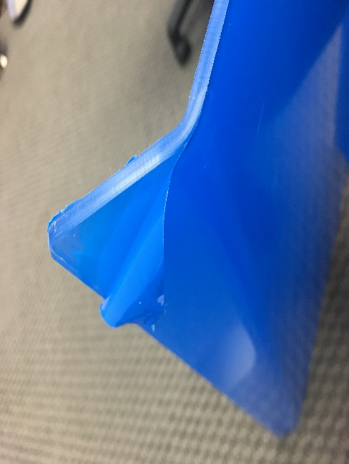
Portable Metal Frame Sneeze guard

Step 1: Peel off the blue protective tape on both sides being careful not to scratch.

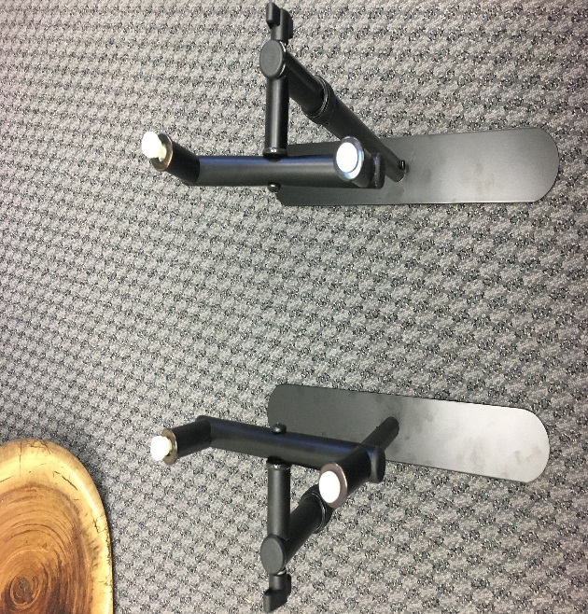

Step 2: Set both stands so that they face each other, as pictured.

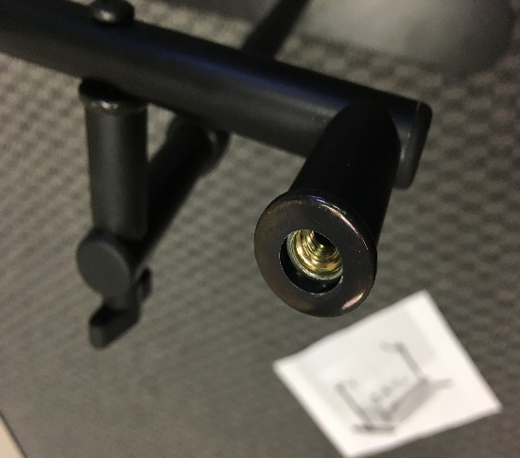
Step 3:

Unscrew the 4
white screws on the top of the stands

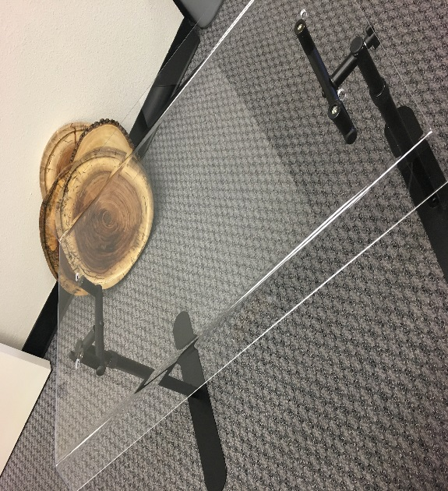
Step 4: Gently place shield on the stands, and continue to insert the white screws back to their original positions.

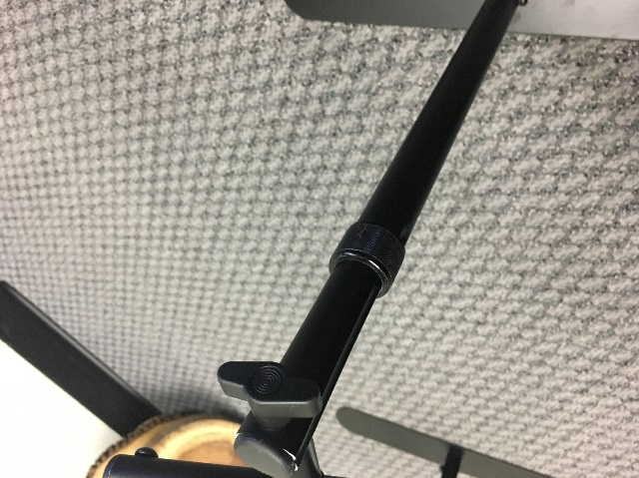
Step 5: Loosen left and right wingnuts until shield is in desired position, then tighten

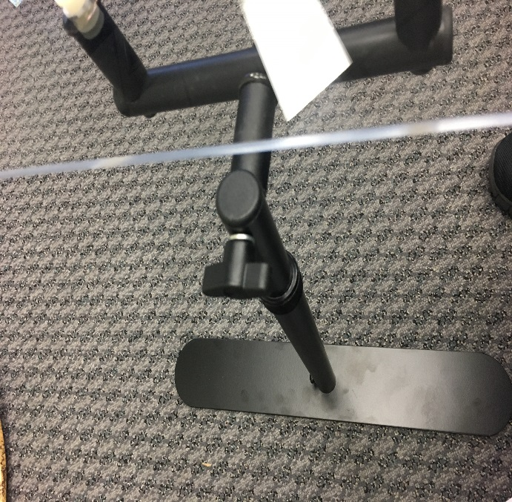
Step 6: Loosen left and right tensioner to adjust height to desired position, then tighten.

That’s It!
